**Method Hiding In C#**

* Method hiding occurs in inheritance relationship when base class and derived class both have a method with same name and same signature.
* When we create the object of derived class it will hide the base class method and will call its own method and this is called method hiding or name hiding in C# inheritance.
* We use “new” keyword in derived function name to show that implementation of the function in derived class is intentional and derived class no longer want to use base class method.

**NOTE**: If we do not use “new” keyword then compiler will raise only warning, but, program will work fine.

**Different Ways To Call A Hidden Base Class Member From Derived Class**

* Use **base** keyword
* Cast child type to parent type and invoke the hidden member.
* ParentClass PC = new ChildClass();
  + PC.hiddenMethod();
* Parent class can have the reference of its child class.
* When we create the object of child class, parent class object is also created.

**Source Code Of Method Hiding**

using System;

using System.Collections.Generic;

using System.Linq;

using System.Text;

using System.Threading.Tasks;

namespace METHOD_HIDING

{

class A

{

public void Print()

{

Console.WriteLine("THIS IS A METHOD OF PARENT CLASS !!");

}

}

class B : A

{

public new void Print()

{

//base.Print();

Console.WriteLine("THIS IS A METHOD OF CHILD CLASS !!");

}

}

class Program

{

static void Main(string[] args)

{

A obj = new B();

obj.Print();

//((A)obj).Print();

Console.ReadLine();

}

}

}

**Difference Between Method Hiding And Method Overriding In C#**

**Method Hiding In C#**

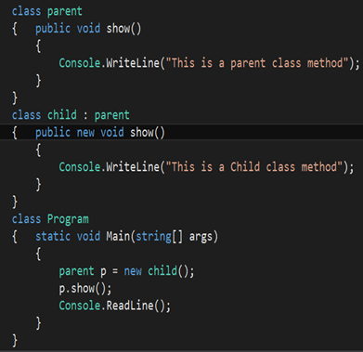

**Output**



**In method hiding**, a base class reference variable pointing to a child class object, will invoke the hidden method of the base class.

**Method Overriding In C#**

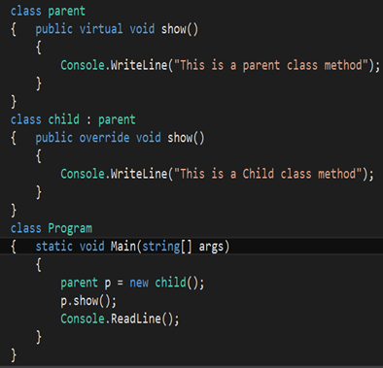

**Output**



**In method overriding,** a base class reference variable pointing to a child class object, will invoke the overridden method of the child class.